Name: _______________________________

Period: _______________________________

**Conformity and counter-culture essay prompt:**

Assess the validity of the statement below. Determine whether you agree, or disagree and to what extent you agree or disagree. Use the documents in the source packet and/or any other valid documents to support your claim.

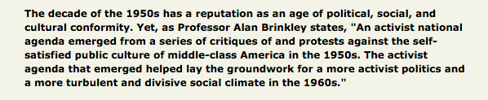

|  |
| --- |
| Agree or Disagree (and to what extent)  Bullet point your evidence: |

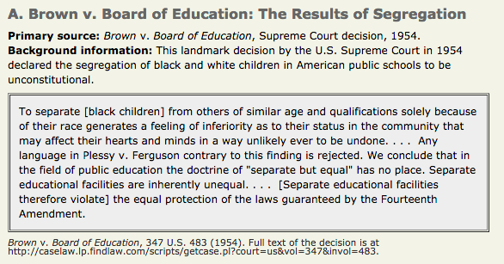

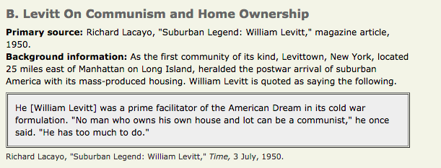

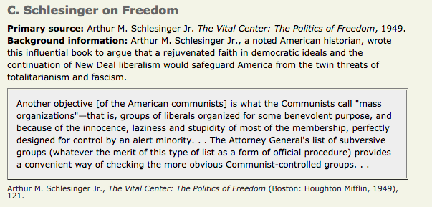

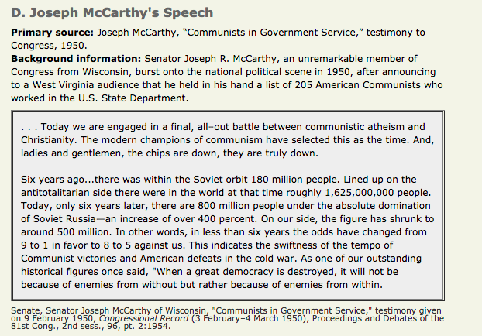

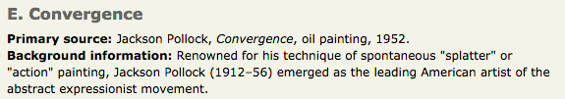

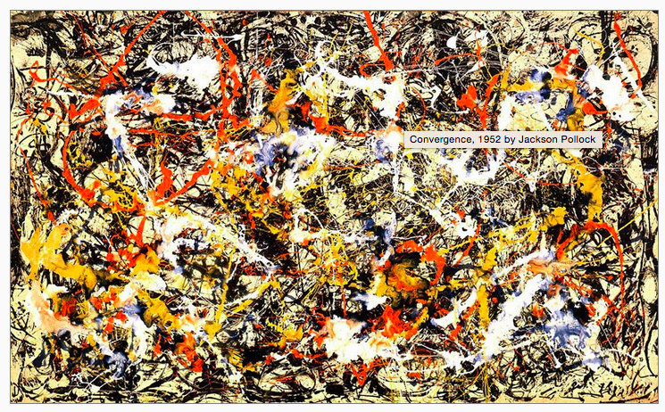

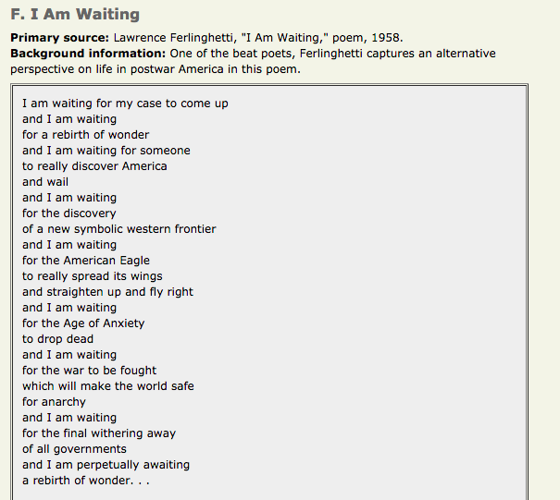

**F Continued**

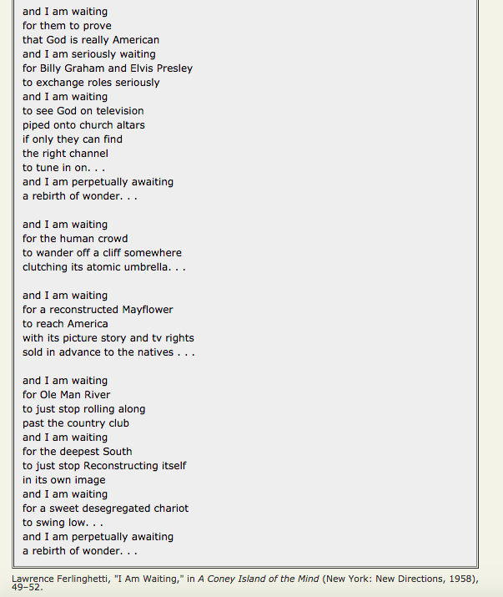

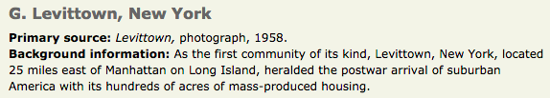



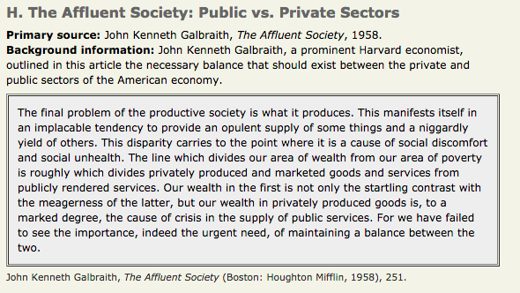

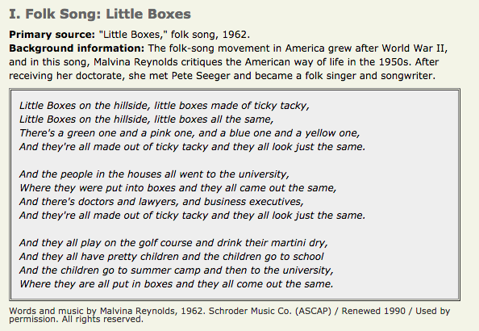

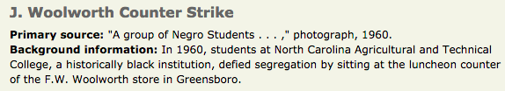

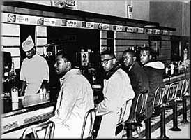

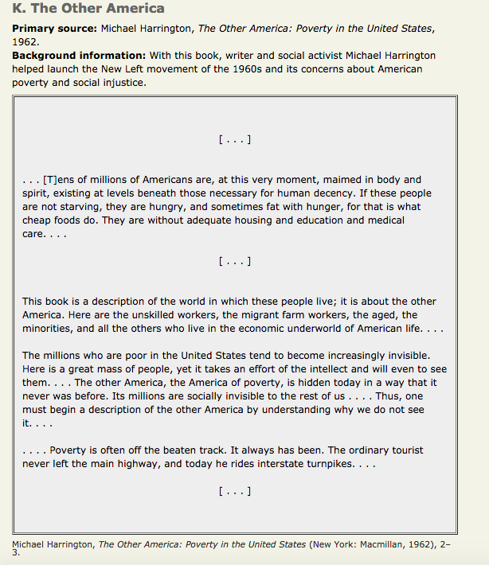

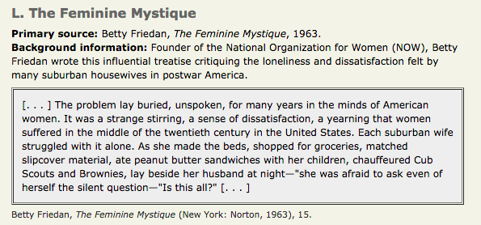

**Calculus**

**English 12**

**MTec- Pharm Tec**

4.0

31