Name: ____________________________________
Period: ____________________________________

Public Policy Day 2: Gun Laws
- Interpreting the intent of the framers of the Constitution is at the heart of the gun control debate. The Second Amendment states: “A well regulated Militia, being necessary to the security of a free State, the right of the people to keep and bear Arms, shall not be infringed.“ Gun rights advocates argue this clearly guarantees the universal right to bear arms. Gun control advocates, however, say it is a conditional right that should be strictly regulated in the interest of public safety.

- In 2010, there were roughly 31,670 gun-related deaths in the U.S. Close to 11,100 were homicides (35%) and about 19,400 (61%) were suicides.

- In the last 30 years, there have been at least 62 mass shootings in 30 states. 25 have occurred since 2006.

- The National Rifle Association was created after the Civil War, in part, to improve American marksmanship skills. It was not until the 1970s that it began to actively oppose most gun control attempts as attacks on civil liberties. Currently, the NRA has more than 4 million members.

- At various points since the 1930s, Congress has enacted a variety of gun control regulations, including licensing; restrictions on certain types of firearms and prohibiting convicted felons from owning guns. In 1972, the Bureau of Alcohol, Tobacco and Firearms was created to enforce these laws.

- One of the biggest loopholes in federal gun control laws is background check provision: only licensed gun dealers are currently required to conduct instant background checks. However, the checks aren’t required at gun shows and other private sales, where about 40 percent of guns are purchased.

- Gun control laws vary widely from state to state. Some states have much stricter rules in place than their neighbors do, and many buyers travel to states with looser regulations to acquire firearms

- In 2010, seven out of 10 states with the strictest regulations also had that lowest gun homicide rates. However, certain states with loose gun regulations - like Maine - also have among the low-est gun homicide rates in the country.

- A number of mass shootings in public settings, including schools and movie theatres, have historically revived the gun control debate. A 1989 school shooting in Stockton, Calif. spurred the state to pass the strictest set of gun laws in the country. It included legislation restricting the sale and use of assault rifles

- Last December’s mass shooting in Newtown, Conn., one of the deadliest in U.S. history, prompted President Obama to call for federal legislation prohibiting the sale of certain semiautomatic rifles and high-capacity magazines, and requiring background checks for all gun buyers. Nearly four months later, after intense lobbying by gun rights groups, the Senate voted on a more moderate piece of legislation. It was narrowly defeated, preserving the status quo.
Go to: http://ww2.kqed.org/lowdown/2012/12/19/the-geography-of-u-s-gun-homicides/

Study the map.
Which 5 states have the lowest murder rate per 100,000 population?

Which 5 states have the highest murder rate per 100,000?

When it comes to national gun laws, the United States is about as far from united as it gets. Beyond the loose set of federal regulations that everyone must follow, there are 50 unique state laws and even more individual county and city rules. It’s resulted in a confusing tapestry of gun regulations that vary drastically depending on where you happen to be. There’s variation in anything from background checks and handgun permit requirements to the sale of semi-automatic weapons and waiting periods. Even rules on allowing firearms on college campuses, in bars, or even in churches can differ across certain state lines.

Federal Law
Federal law prohibits buying or transferring firearms across state lines, owning machine guns and other certain high capacity devices, and bringing guns onto school zones (“except as authorized”). Under the law, you also can’t buy or possess a gun if you’ve been convicted of domestic assault or other serious crimes, dishonorably discharged from the military, or if you have a restraining order against you. The prohibition also includes fugitives, drug users, illegal immigrants, and those deemed mentally ill or institutionalized.
Bullet point the restrictions that apply to all states:

Federal “Loopholes”
The background check loophole
Advocates of strong gun laws often point to the many loopholes in federal gun law. One of the biggest is the lack of required background checks for private guns sales. Under the law, all licensed gun dealers throughout the country must conduct instant background checks (using a state or FBI database) on potential buyers. But federal law does not require those checks at gun shows and other private sales – including guns bought online- where as many as 40 percent of gun purchases reportedly occur. For these types of sales, it’s often no questions asked.

And while some states – like California and New York – have universal background check requirements extending to private sales, the majority of states do not. Closing that loophole was one of the major talking points to come out of the gun task force convened by Vice President Joe Biden earlier last month.

Advocates for stronger federal gun control laws argue that if one state has a strict gun policy but neighboring states don’t, then what’s to stop gun buyers from just going to wherever it’s easiest to buy what they’re looking for?

California is a perfect example. Even though It has some of the toughest gun regulations in the country, it borders Arizona and Nevada, both of which

have some of the loosest: they both allow the sale of semi-automatic assault weapons and don’t require waiting periods or background checks at gun shows.

The issue is of particular relevance in cities like Chicago and Oakland, which have alarmingly high gun homicide rates despite very strict local gun control measures. As one Chicago city official put it:

“Chicago is not an island. Were only as strong as the weakest gun law in surrounding states.”

Do you believe the background check loophole should be changed? Why or why not.

Are States With Tough Gun Laws Actually Safer?
The Law Center to Prevent Gun Violence, an advocacy group pushing for tougher regulations, assigned every state a grade based on 29 different policy approaches to regulating firearms and ammunition. California topped the list with an A-. New York, which now requires background checks for ammunition sales, has since surpassed it in the toughness of its gun laws. It’s the first state to enact such legislation following the Newtown shooting. And efforts in a handful of other states — including California and Colorado to strengthen gun laws are already underway.

The Center points to 2010 statistics showing that seven out of 10 states with the strictest regulations also had that lowest gun homicide rates.

But gun rights advocates opposed to tighter regulations argue that this correlation is inconclusive and misleading. They commonly counter that stricter regulations don’t do anything to prevent criminals from getting ahold of guns they simply prevent law-abiding citizens from being able to protect themselves. Many also point to states like Maine, which has some of the loosest regulations in the country (it received an F grade by gun control groups, but also has among the lowest gun homicide rates in the country). On the contrary, they argue, the strict gun laws in cities like Chicago and Washington D.C. have failed to prevent those rising homicide rates in those places.

“The gun laws in Chicago only restrict the law-abiding citizens and they’ve essentially made the citizens prey,” Richard A. Pearson, executive director of the Illinois State Rifle Association told the NY Times.

California vs. South Dakota: the toughest and loosest gun laws
Despite its relatively low rate of gun homicides, South Dakota got smacked with an F grade by the Center to Prevent Gun Violence, which identified it as the state with the nation’s weakest gun laws. Here’s how the two states compare:

California: toughest gun laws  - Requires all gun sales (private or otherwise) to be processed through a licensed dealer, requiring a background check  - Requires gun dealers to obtain a state license (rather than just a federal one)  - Bans most assault weapons and 50 caliber rifles, and prohibits the sale or transfer of large capacity ammunition magazines  - Requires handgun purchasers to obtain a license, after passing a written test  - Regulates its gun shows  - Limits handgun purchases to one per person per month  - Imposes a ten-day waiting period prior to the sale or transfer of a firearm  - Maintains permanent records of firearm sales  - Gives local law enforcement discretion to deny a license to carry a concealed weapon  - Gives local governments authority to regulate firearms and ammunition (although the state legislature has expressly removed this authority in certain areas). | South Dakota: loosest gun laws  - Does not require a background checks for private sales  - Repealed its 48-hour waiting period for handgun purchases  - Does not require gun dealers to obtain a state license  - Does not regulate the transfer or possession of assault weapons, 50 caliber rifles, or large capacity ammunition magazines  - Does not require gun owners to obtain a license, register their firearms, or report lost or stolen firearms  - Does not require the reporting of mentally ill individuals to the federal database used for firearm purchaser background checks  - Does not limit the number of firearms that may be purchased at one time  - Does not regulate unsafe handguns  - Does not allow local governments to regulate firearms  - Does not have local law enforcement discretion to deny a concealed handgun permit

Study the gun laws in the two states. Bullet-point the laws that you agree with.

Regardless of where you stand on gun control, the fact remains that America is one gun-toting country. There are 89 guns for every 100 civilians, according to the 2011 Small Arms Survey. That amounts to roughly 270 million guns owned nationwide, far and away the highest gun ownership rate in the world. With less than 5 percent of the world’s population, the U.S. is home to anywhere between 35 and 50 percent of all civilian-owned guns on earth.

And while America certainly does not have the highest firearms-related homicide rate in the world (it ranks 28th), our rate is more than four times that of any other industrialized country (including all of Europe, Japan, Australia, Turkey and India): in 2011, there were well over 9,000 gun-related homicides (nearly 70 percent of all homicides committed), or roughly three per 100,000 population, according to the United Nations Office on Drugs and Crime. That’s about 20 times the average rate of all other developed nations, according to the Washington Post.

In contrast, Great Britain has a gun ownership rate of about 6 guns for every 100 civilians. Last year it had 41 gun-related homicides, or .07 per 100,000 population. Meanwhile, Finland, where there are 45 guns per 100 civilians, had only 24 gun homicides in 2011, a rate of .45 per 100,000 population.

Explain your thoughts on the previous paragraph:
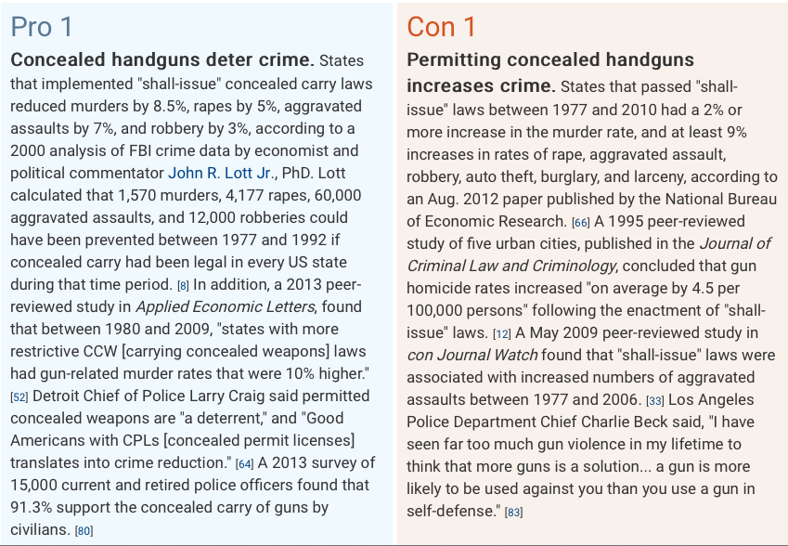

Which side do you agree with? Explain.
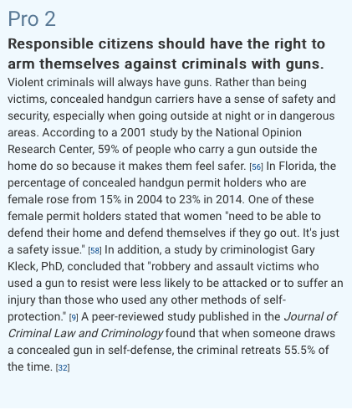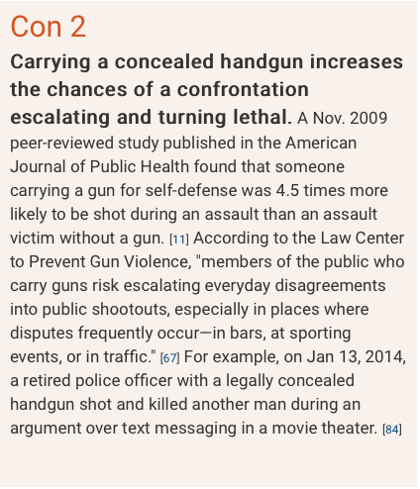

Which side do you agree with? Explain.

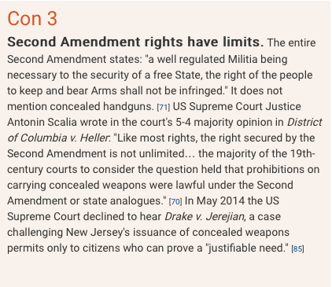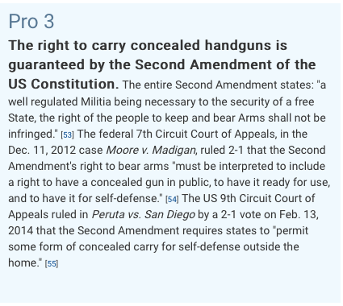
Which side do you agree with? Explain.
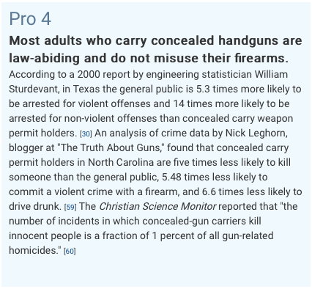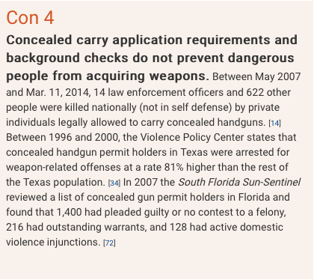
Which side do you agree with? Explain.

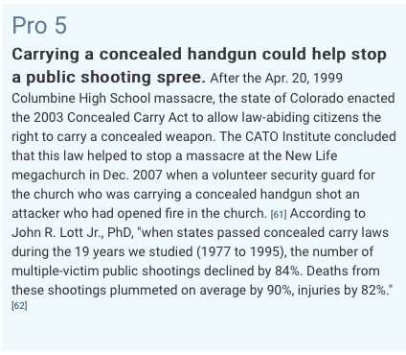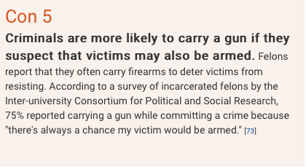
Which side do you agree with? Explain.

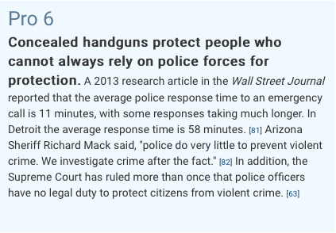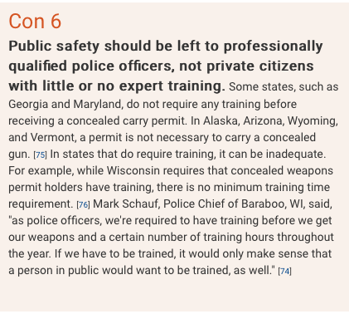
Which side do you agree with? Explain.

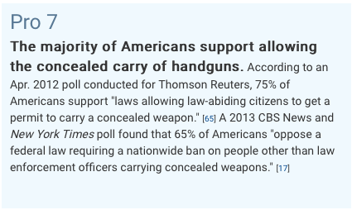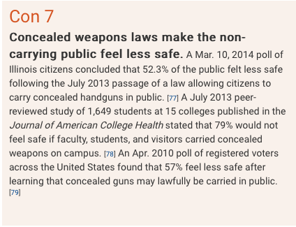

Which side do you agree with? Explain.

