Name: _______________________________________
Period: _______________________________________
Vietnam War: Read and Respond

 factors that drew the United States into conflict with North Vietnam and Ho Chi Minh.
H□  the Vietnam War changed the nature of warfare?

Answer the following questions regarding this document:
Document A: The Vietnamese Declaration of Independence
President Ho Chi Minh delivered this address in Hanoi on September 2nd, 1945.

- Why might Ho Chi Minh have borrowed phrases from the United States Declaration of Independence and the French Rights of Man and the Citizen?

- According to the Vietnamese Declaration of Independence, how were the Vietnamese treated under French Imperial rule?

- What are some of the Vietnamese grievances against the French? Provide
specific examples.

- Who ruled Vietnam after 1940? Why?

- How and why did the Vietnamese justify their independence from France?

- Was Vietnam an independent nation following World War II? Why or why not?

Document B: Telegram from Ho Chi Minh to President Harry S. Truman

- Why does Ho Chi Minh appeal to President Harry S. Truman in this 1946 telegram?

- What is the nature of the problem in Vietnam as defined by Ho Chi Minh in this telegram?

- Ho Chi Minh calls on the American people to “interfere urgently” in support of Vietnamese independence. Do you expect the United States to support Ho Chi Minh? Explain. What could the United States have done, had they wanted to intervene?

Gulf Of Tonkin Resolution
- Why did Johnson claim that North Vietnam deliberately attacked the United States? What evidence does he offer to support this assertion?
Document C: Gulf of Tonkin Resolution

- What four propositions does Johnson make in his speech?

- How does Johnson rationalize U.S. involvement in Vietnam?

- In the Gulf of Tonkin Resolution, what does the United States regard as its national interest?

- Why do you think the Senate passed the Gulf of Tonkin Resolution instead of
just declaring war?

My Lai Massacre
My Lai Massacre photograph

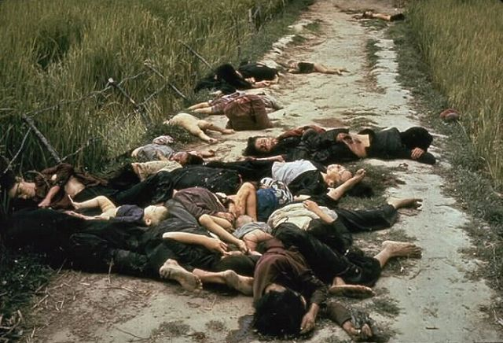

Source: This photograph, taken by Robert Haeberle of Life magazine, appeared in magazines and newspapers throughout the country.

Answer the following questions:

- Roughly how many people appear to be dead in the photograph?

- What appear to be the ages of the people in the photograph?

- How are these people dressed?

- What can we assume about these people based on their dress?

- How did these people die?

- What message do you think the photographer is trying to send? Give reasons for your answer.

Document D: “The Massacre at My Lai” magazine article

Read the article and answer the following questions:

- Why do you think the My Lai Massacre occurred?

- Why would U.S. soldiers kill innocent Vietnamese civilians?

- How do you think Americans at the time reacted to these photographs?

- How did the My Lai Massacre affect public support for the war?

Antiwar Protests
Document E: Antiwar Protests Songs and Lyrics

After listening to the songs and/or reading the lyrics, answer the following questions:

- What is the attitude towards the Vietnam War? How can we tell?

- Why do you think the song was written?

- Do you think these songs were more or less effective than other forms of protest against the war (e.g., public demonstrations, civil disobedience)? Be sure to explain your reasoning.

- If you were drafted to fight in the Vietnam War in 1969, would you have gone? Why or why not? What factors would have influenced your decision? Explain.

Vietnamization and the End to War
Document F: Nixon’s 1969 speech on Vietnamization

1. What does Nixon say are the questions that are “on the minds of many of you
listening to me?”

2. What is “the great question” that Nixon asks?

3. What did Nixon conclude in January? Why?

4. What was the Vietnamization plan?

5. What does Nixon say are the two choices “open to us if we want to end this war?”
Which of the two did he choose? Why?

6. How did Nixon justify his course of action?

7. What did Nixon mean by the following statement: “Because let us understand: North Vietnam cannot defeat or humiliate the United States. Only Americans can do that?” Explain.

Document G: Nixon’s “Peace with Honor” speech

- Why did Nixon keep his negotiations secret?

- Did Vietnamization provide a solution to the “quagmire” of the war? Explain.

- Did the Paris Accords end the war? Explain.

- Do you think the United States achieved “peace with honor?” Give evidence
to support your conclusion.

